

**________________________________________________________________**

**UNIVERSITY OF PETROLEUM & ENERGY STUDIES**

**School of Engineering Studies**

**Dehradun**

**LABORATORY MANUAL**

**BASIC ELCTRONICS LAB**

**DEPARTMENT: ELECTRICAL & ELECTRONICS ENGINEERING**

**Every student inside the laboratory should follow the following rules.**

GENERAL INSTRUCTIONS

1. Previous experiment write up should be brought to the lab and submit to the in-charge. Without it they will not be allowed to perform next experiment and will be marked absent.

2. They have to attend the lab in time. Anybody coming late more than 5 minutes will be marked absent for that day.

3. They cannot leave the labs without the permission of the in-charge. Any body found violating the rules would be marked absent.

4. The instrument allotted to a particular group of students, and if it is found not functioning properly after they return the blame will go to the whole group. So they should check the instruments before and after delivery.

5. Students are required to maintain the decorum of the labs

|  |  |
| --- | --- |
| S. NO. | NAME OF EXPERIMENT |
| 1. | To study the various electronics components (diode, resistor, transistor, capacitors, IC’s etc.) and measuring instruments (multimeter, CRO,DSO etc.) |
| 2. | To Study and plot the V-I characteristics of P-N Junction diode and Zener Diode |
| 3. | To Study and set up a half wave and full wave rectifier circuit. And to calculate its form factor, Ripple factor and efficiency |
| 4. | To Study clipper circuits and plot the wave form |
| 5. | To Study clamper circuits and plot the wave form |
| 6. | Study of transistor characteristics common emitter (NPN) |
| 7. | Study of transistor characteristics common base (NPN) |
| 8. | To design an inverting amplifier with a gain of -10 (using op-amp) |
| 9. | To design a non- inverting amplifier with a gain of  10 (using op-amp) |
| 10. | To design an adder circuit for summing 3 input voltage signals (using op-amp) |

**LIST OF EXPERIMENTS**

**VALUE ADDED EXPERIEMTNS**

|  |  |
| --- | --- |
| S. NO. | NAME OF EXPERIMENT |
| 1. | Design a DC power supply using regulator IC (7405/7412) |
| 2. | To utilize transistor as a switch for digital circuit application |

**EXPERIMENT NO-1**

**TO STUDY THE VARIOUS ELECTRONICS COMPONENTS (DIODE, RESISTOR, TRANSISTOR, CAPACITORS, IC’S ETC.) AND MEASURING INSTRUMENTS (MULTIMETER, CRO, DSO ETC.)**

**Aim: To study the various electronics components (diode, resistor, transistor, capacitors, IC’s etc.) and measuring instruments (multimeter, CRO,DSO etc.)**

**Introduction-**An electronic circuit is composed of various types of components. Some of these components are termed as active components because they take part in the transformation of the energy while other components, which only dissipate or store energy, are called as passive elements. The vacuum tubes, rectifier, transistors are some of-the common active while the resistances, which dissipate the power and energy storing elements such as capacitances and inductances are known as passive elements. The transformers may be regarded as a matching device. The success of any electronic circuit depends not only on proper selection of the active elements but on the passive and matching elements too. The proper function, of an active device is decided by the proper values of these passive elements. Hence the selection of these elements such as resistances, inductances, capacitance, and transformers not only require the proper attention, but also decide the proper function of the active devices as well as the circuit as a whole.

Here we shall discuss about some important electronic components and their characteristics, particularly used in biomedical instruments.

**Electronics components:** These can be classified into

(I)-**Active Components**

(II)- **Passive Components**

**(I)-Active Components:** They can be further classified as**-**Semiconductor Devices: Semiconductor diode, zener diode, and varactor diode etc. Uni-junction transistor, Bipolar junction transistor (BJT), FET, silicon, Controlled rectifier etc.

**Vacuum Tube Devices:** Vacuum tube diode, triode, Tetrode, Pentode, Hexode, Heptode etc.

**Gas Tube Devices:** Gas diodes, Threatens etc.

**Photo Sensitivity Devices:** Gas photodiodes, photo multiplier tubes, photodiodes, light emitting diode, photosensitive transistor etc.

Though there are devices, which are specific to particular frequency range and applications like microwave devices etc.

**(II)Passive Components:** Components like resistance, capacitanceinductance, and fall in this class.

**Resistor**

A resistor is an electronics/electrical component that limits or regulates the flow of electrical current in an electronic circuit. Resistors can also be used to provide a specific voltage for an active device such as a transistor. All other factors being equal, in a direct-current (DC) circuit, the current through a resistor is inversely proportional to its resistance, and directly proportional to the voltage across it. This is the well-known Ohm's Law. In alternating-current (AC) circuits, this rule also applies as long as the resistor does not contain inductance or capacitance. Resistors can be made to control the flow of current, to work as Voltage dividers, to dissipate power and it can shape electrical waves when used in combination of other components. Basic unit is ohms, (Ω).

**(A)-Carbon-composition resistor**

Resistors can be fabricated in a variety of ways. The most common type in electronic devices and systems is the carbon-composition resistor. Fine granulated carbon (graphite) is mixed with clay and hardened. The resistance depends on the proportion of carbon to clay; the higher this ratio, the lower the resistance.

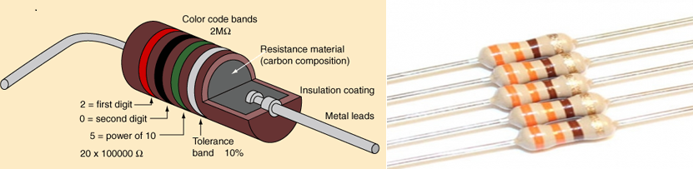

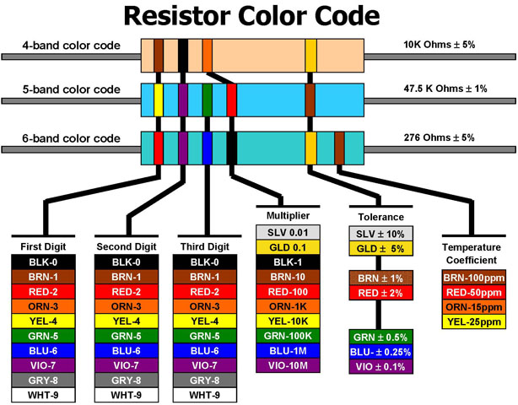

#### 3Band Description

The number of bands is important because the decoding changes based upon the number of color bands. There are three common types: 3 band, 4 band, 5 band, and 6 band resistors. For the 3 band resistor:

**Band 1** – First significant digit.  
**Band 2** – Second significant digit  
**Band 3** – Multiplier

#### 4 Band Description

The number of bands is important because the decoding changes based upon the number of color bands. There are three common types: 4 band, 5 band, and 6 band resistors. For the 4 band resistor:

**Band 1** – First significant digit.  
**Band 2** – Second significant digit  
**Band 3** – Multiplier  
**Band 4** – Tolerance

#### 5 Band Description

The number of bands is important because the decoding changes based upon the number of color bands. There are three common types: 4 band, 5 band, and 6 band resistors. For the 5 band resistor:

**Band 1** – First significant digit.  
**Band 2** – Second significant digit  
**Band 3** – Third significant digit  
**Band 4** – Multiplier  
**Band 5** – Tolerance

#### 6 Band Description

The number of bands is important because the decoding changes based upon the number of color bands. There are three common types: 4 band, 5 band, and 6 band resistors. For the 6 band resistor:

**Band 1** – first significant digit.  
**Band 2** – second significant digit  
**Band 3** – third significant digit  
**Band 4** – Multiplier  
**Band 5** – Tolerance  
**Band 6** – Temperature Coefficient (Tempco)

**(B)-POTENTIOMETER-** Apotentiometer, informally a pot, is a three-terminal resistor with a sliding or rotating contact that forms an adjustable voltage divider. If only two terminals are used, one end and the wiper, it acts as a variable resistor or rheostat.The measuring instrument called a potentiometer is essentially a voltage divider used for measuring electric potential (voltage); the component is an implementation of the same principle, hence its name.Potentiometers are commonly used to control electrical devices such as volume controls on audio equipment. Potentiometers operated by a mechanism can be used as position transducers, for example, in a joystick. Potentiometers are rarely used to directly control significant power (more than a watt), since the power dissipated in the potentiometer would be comparable to the power in the controlled load.

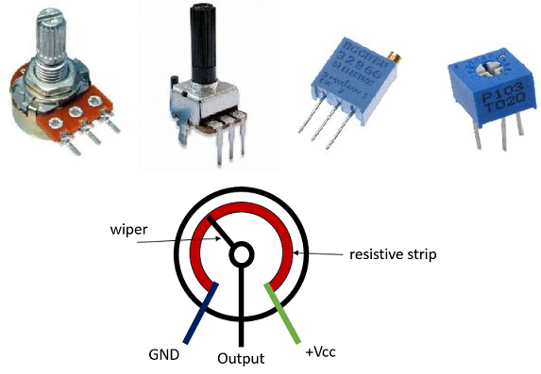

**Capacitors**

The comparisons between the different types of capacitor is generally made with regards to the dielectric used between the plates. Like resistors, there are also variable types of capacitors which allow us to vary their capacitance value for use in radio or “frequency tuning” type circuits. Commercial types of capacitors are made from metallic foil interlaced with thin sheets of either paraffin-impregnated paper or Mylar as the dielectric material. Some capacitors look like tubes, this is because the metal foil plates are rolled up into a cylinder to form a small package with the insulating dielectric material sandwiched in between them. Small capacitors are often constructed from ceramic materials and then dipped into an epoxy resin to seal them. Either way, capacitors play an important part in electronic circuits so here are a few of the more “common” types of capacitor available.

**(A)-Dielectric Capacitor** -**Dielectric Capacitors** are usually of the variable type were a continuous variation of capacitance is required for tuning transmitters, receivers and transistor radios. Variable dielectric capacitors are multi-plate air-spaced types that have a set of fixed plates (the stator vanes) and a set of movable plates (the rotor vanes) which move in between the fixed plates. The position of the moving plates with respect to the fixed plates determines the overall capacitance value. The capacitance is generally at maximum when the two sets of plates are fully meshed together. High voltage type tuning capacitors have relatively large spacing’s or air-gaps between the plates with breakdown voltages reaching many thousands of volts.

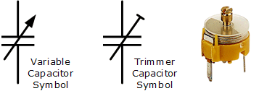

Variable Capacitor

As well as the continuously variable types, preset type variable capacitors are also available called **Trimmers**. These are generally small devices that can be adjusted or “pre-set” to a particular capacitance value with the aid of a small screwdriver and are available in very small capacitance’s of 500pF or less and are non-polarized.

**(B)-Film Capacitor-Film Capacitors** are the most commonly available of all types of capacitors, consisting of a relatively large family of capacitors with the difference being in their dielectric properties. These include polyester (Mylar), polystyrene, polypropylene, polycarbonate, metalized paper, Teflon etc. Film type capacitors are available in capacitance ranges from as small as 5pF to as large as 100uF depending upon the actual type of capacitor and its voltage rating. Film capacitors also come in an assortment of shapes and case styles which include:

* Wrap & Fill (Oval & Round)  –  where the capacitor is wrapped in a tight plastic tape and have the ends filled with epoxy to seal them.
* Epoxy Case (Rectangular & Round)  –  where the capacitor is encased in a molded plastic shell which is then filled with epoxy.
* Metal Hermetically Sealed (Rectangular & Round)  –  where the capacitor is encased in a metal tube or can and again sealed with epoxy. With all the above case styles available in both Axial and Radial Leads.

**Film Capacitors** which use polystyrene, polycarbonate or Teflon as their dielectrics are sometimes called “Plastic capacitors”. The construction of plastic film capacitors is similar to that for paper film capacitors but use a plastic film instead of paper. The main advantage of plastic film capacitors compared to impregnated-paper types is that they operate well under conditions of high temperature, have smaller tolerances, a very long service life and high reliability. Examples of film capacitors are the rectangular metalized film and cylindrical film & foil types as shown below.

### Radial Lead Type

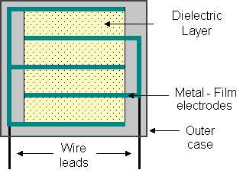

**Axial Lead Type**

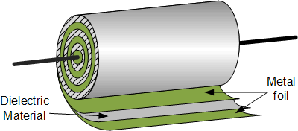

The film and foil types of capacitors are made from long thin strips of thin metal foil with the dielectric material sandwiched together which are wound into a tight roll and then sealed in paper or metal tubes.

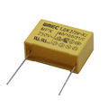

**Film Capacitor**

These film types require a much thicker dielectric film to reduce the risk of tears or punctures in the film, and is therefore more suited to lower capacitance values and larger case sizes.

Metalised foil capacitors have the conductive film metalised sprayed directly onto each side of the dielectric which gives the capacitor self-healing properties and can therefore use much thinner dielectric films. This allows for higher capacitance values and smaller case sizes for a given capacitance. Film and foil capacitors are generally used for higher power and more precise applications.

**(C)-Ceramic Capacitors-Ceramic Capacitors or Disc Capacitors** as they are generally called, are made by coating two sides of a small porcelain or ceramic disc with silver and are then stacked together to make a capacitor. For very low capacitance values a single ceramic disc of about 3-6mm is used. Ceramic capacitors have a high dielectric constant (High-K) and are available so that relatively high capacitance’s can be obtained in a small physical size.

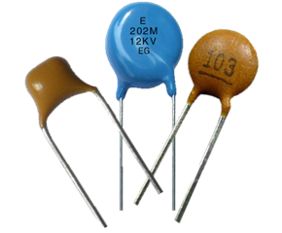

**Ceramic Capacitor**

They exhibit large non-linear changes in capacitance against temperature and as a result are used as de-coupling or by-pass capacitors as they are also non-polarized devices. Ceramic capacitors have values ranging from a few Pico farads to one or two microfarads, (μF) but their voltage ratings are generally quite low.

Ceramic types of capacitors generally have a 3-digit code printed onto their body to identify their capacitance value in Pico-farads. Generally the first two digits indicate the capacitors value and the third digit indicates the number of zero’s to be added. For example, a ceramic disc capacitor with the markings 103 would indicate 10 and 3 zero’s in Pico farads which is equivalent to 10,000 pF or 10nF.Likewise, the digits 104 would indicate 10 and 4 zero’s in Pico farads which is equivalent to 100,000 pF or 100nF and so on. So on the image of the ceramic capacitor above the numbers 154 indicate 15 and 4 zero’s in Pico farads which is equivalent to 150,000 pF or 150nF or 0.15uF. Letter codes are sometimes used to indicate their tolerance value such as: J = 5%, K = 10% or M = 20% etc.

**(D)-Electrolytic Capacitors-Electrolytic capacitors** are generally used when very large capacitance values are required. Here instead of using a very thin metallic film layer for one of the electrodes, a semi-liquid electrolyte solution in the form of a jelly or paste is used which serves as the second electrode (usually the cathode).The dielectric is a very thin layer of oxide which is grown electro-chemically in production with the thickness of the film being less than ten microns. This insulating layer is so thin that it is possible to make capacitors with a large value of capacitance for a small physical size as the distance between the plates, d is very small.

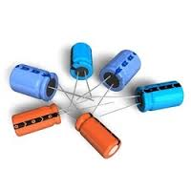**Electrolytic Capacitor**

The majority of electrolytic types of capacitors are Polarized, that is the DC voltage applied to the capacitor terminals must be of the correct polarity, i.e. positive to the positive terminal and negative to the negative terminal as an incorrect polarization will break down the insulating oxide layer and permanent damage may result.

All polarized electrolytic capacitors have their polarity clearly marked with a negative sign to indicate the negative terminal and this polarity must be followed.

**Electrolytic Capacitors** are generally used in DC power supply circuits due to their large capacitance’s and small size to help reduce the ripple voltage or for coupling and decoupling applications. One main disadvantage of electrolytic capacitors is their relatively low voltage rating and due to the polarization of electrolytic capacitors, it follows then that they must not be used on AC supplies. Electrolytic generally come in two basic forms; **Aluminum Electrolytic Capacitors**and**Tantalum Electrolytic Capacitors.**

### Electrolytic Capacitor

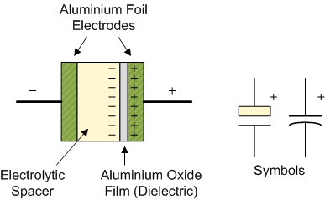

**Inductors-**

Like capacitors, inductors also store energy in one part of AC cycle and return it during the next part of the cycle. Inductance is that property of a device that reacts against a change in current through the device. Inductors are components designed for use in circuits to resist changes in current and thus serve important control functions. Inductor designed is based on the principle that a varying magnetic field induces a voltage in any conductor in that field. Thus, a practical inductor may simply be a coil wire. The current in each loop of the coil produces a magnetic field that passes through neighboring loops. If the current through the coil is constant the magnetic field is constant and no action takes place. A change in the current, however, 8 produces a change in the magnetic field. The energy absorbed or released

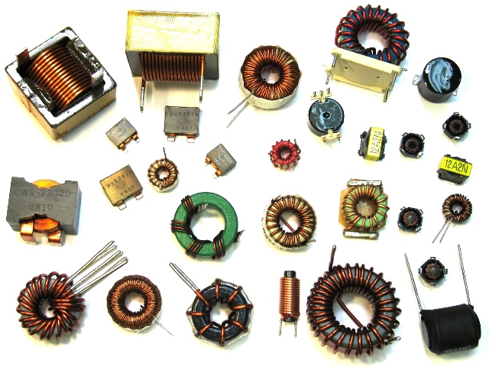

from the changing magnetic field reacts against the change in current, and this is exhibited as in induced voltage (electromotive force, Emf), which is counter to the change in applied voltage. The inductor thus behaves as an impedance to ac current. The counter emf is directly proportional to the rate of change of current through the coil (VL=L[di/dt]). The proportionality constant is the inductance L, which has the unit of henrys (H) in an A.C circuit, as shown in, the inductor offers reactance to alternating current. The inductive reactance XL has the units of ohms and is given by XL = wL = 2πfL Total inductance L = L1 + L2 + L3 ----------- Inductances in parallel: 1/L = 1/L1 + 1/L2 + 1/L3

**Diode**

A diode is a specialized electronic component with two electrodes called the anode and thecathode. Most diodes are made with semiconductor materials such as silicon, germanium, or selenium. Some diodes are comprised of metal electrodes in a chamber evacuated or filled with a pure elemental gas at low pressure. Diodes can be used as rectifiers, signal limiters, voltage regulators, switches, signal modulators, signal mixers, signal demodulators, and oscillators.

### (A)- P_N junction silicon diode

**P-N junction diode** is the most fundamental and the simplest electronics device. When one side of an [intrinsic semiconductor](https://www.electrical4u.com/intrinsic-silicon-and-extrinsic-silicon/) is doped with acceptor i.e., one side is made p-type by doping with n-type material, a p-n junction diode is formed. This is a two terminal device. It appeared in 1950’s. **P-N junction** can be step graded or linearly graded. In step graded the concentration of dopants both, in n - side and in p - side are constant up to the junction. But in linearly graded junction, the doping concentration varies almost linearly with the distance from the junction.

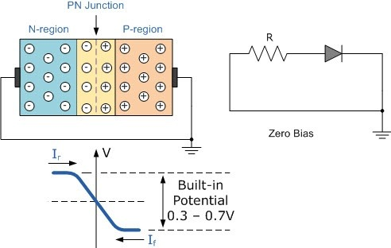

When the **P-N diode** is in unbiased condition that is no [voltage](https://www.electrical4u.com/voltage-or-electric-potential-difference/) is applied across it, electrons will defuse through the junction to p-side and holes will defuse through the junction to n-side and they combine with each other. Thus the acceptor atom near the p-side and donor atom near n-side are left unutilized. An electron field is generated by these uncovered charges. This opposes further diffusion of carriers. So, no movement of region is known as space charge or depletion region.

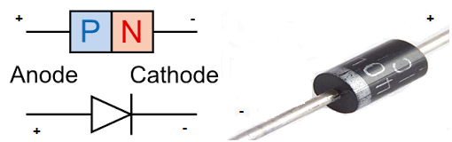

If, we apply forwards bias to the **p-n junction diode**. That means if positive side of the battery is connected to the p – side, then the depletion regions width decreases and carriers flow across the junction. If the bias is reversed the depletion width increases and no charge can flow across the junction.

### (B)-Zener Diode

A zener diode is like a normal diode, but instead of being destroyed by a big reverse voltage, it lets electricity through. The voltage needed for this is called the breakdown voltage or Zener voltage. Because it is built with a known breakdown voltage it can be used supply a known voltage.

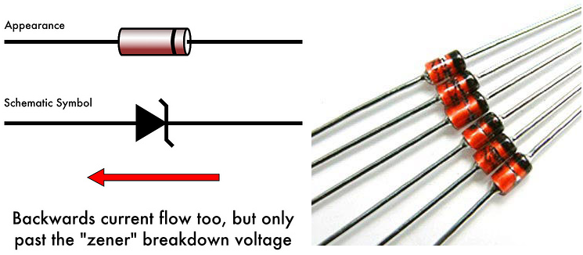

### (C)-Light-Emitting Diode (LED)

An LED produces light when electricity flows through it. It is a longer lasting and more efficient way of creating light than incandescent light bulbs. Depending on how it was made, the LED can make different colors. LEDs were first used in the 1970's. The light-emitting diode may eventually replace the light bulb as developing technology makes it brighter and cheaper (it is already more efficient and lasts longer). In the 1970's the LEDs were used to show numbers in appliances such as calculators, and as a way to show the power was on for larger appliances.

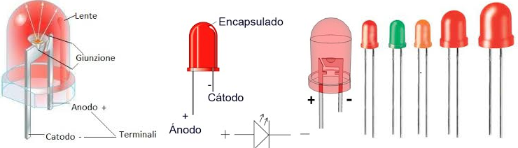

### (D)-Photo diode

A photodiode is a photo detector (the opposite of a light-emitting diode). It responds to light that comes in. Photodiodes have a window or optical fiber connection, which lets light in to the sensitive part of the diode. Diodes usually have strong resistance; the light reduces the resistance.

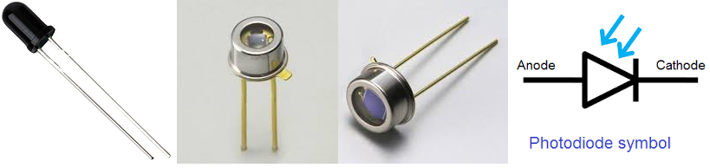

### Voltage Regulator IC (78XX & 78XX)

**A voltage regulator** is one of the most widely used electronic circuitry in any device. A regulated voltage (without fluctuations & noise levels) is very important for the smooth functioning of many digital electronic devices. A common case is with micro controllers, where a smooth regulated input voltage must be supplied for the micro controller to function smoothly

## Nomenclature and packaging

For ICs within the 78xx family, the xx is replaced with two digits, indicating the output [voltage](https://en.wikipedia.org/wiki/Voltage) (for example, the 7805 has a 5-volt output, while the 7812 produces 12 volts). The 78xx line are positive voltage regulators: they produce a voltage that is positive relative to a common ground. There is a related line of **79xx** devices which are complementary negative voltage regulators. 78xx and 79xx ICs can be used in combination to provide positive and negative supply voltages in the same circuit.[[1]](https://en.wikipedia.org/wiki/78xx#cite_note-Rashid2011-1)

78xx ICs have three terminals and are commonly found in the TO-220 form factor, although they are available in surface-mount, TO-92, and TO-3 packages. These devices support an input voltage anywhere from around 2.5 volts over the intended output voltage up to a maximum of 35 to 40 volts depending on the model, and typically provide 1 or 1.5 amperes of current (though smaller or larger packages may have a lower or higher current rating)

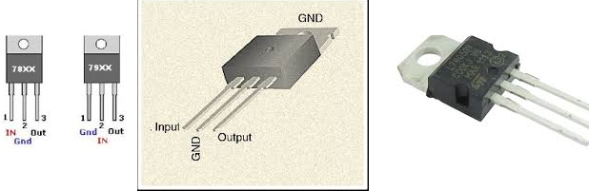

**Family members**

### 78xx

There are common configurations for 78xx ICs, including 7805 (5 V), 7806 (6 V), 7808 (8 V), 7809 (9 V), 7810 (10 V), 7812 (12 V), 7815 (15 V), 7818 (18 V), and 7824 (24 V) versions. The 7805 is the most common, as its regulated 5-volt supply provides a convenient power source for most TTL components.

Less common are lower-power versions such as the LM78Mxx series (500 mA) and LM78Lxx series (100 mA) from National Semiconductor. Some devices provide slightly different voltages than usual, such as the LM78L62 (6.2 volts) and LM78L82 (8.2 volts) as well as the STMicroelectronics L78L33ACZ (3.3 volts).

**Transistors**

Transistor is a semiconductor device which is used to amplify the signals as well as in switching circuits. Generally transistor is made of solid material which contains three terminals such as emitter (E), Base (B) and Collector (C) for connections with other components in the circuit. Some transistors contains fourth terminal also i.e. substrate (S). Transistor is one of the active components. From the time of first transistor invention to present days the transistors are classified into different types depending on either construction or operation, they are explained using tree diagram as below.

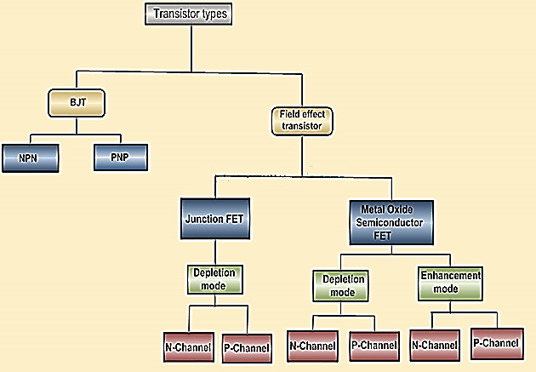

The transistors classification can be understood by observing the above tree diagram. Transistors are basically classified into two types; they are Bipolar Junction Transistors (BJT) and Field Effect Transistors (FET). The BJTs are again classified into NPN and PNP transistors. The FET transistors are classified into JFET and MOSFET. Junction FET transistors are classified into N-channel JFET and P-channel JFET depending on their function. MOSFET transistors are classified into Depletion mode and Enhancement mode. Again depletion and enhancement mode transistors are classified into N-channel JFET and P-channel.

Nowadays the vacuum tubes are replaced with transistors because the transistors have more benefits over vacuum tubes. Transistors are small in size and it requires low voltage for operation and also it has low power dissipation. Due to these reasons the transistor is used in many applications such as amplifiers, switching circuits, oscillators and also in almost all electronic circuits.

### ****Types of Transistors****

Transistor is the proper arrangement of different semiconductor materials. General semiconductor materials used for transistor are silicon, germanium, and gallium-arsenide. Basically the transistors are classified depending on their structure. Each type of transistors has their own characteristics, advantages and disadvantages.Some transistors are designed primarily for switching purpose, other side some are designed for amplification purpose and some transistors are designed for both amplification and switching purposes. Depending on the structure the transistors are classified into BJT and FET.

**Junction Transistors-**

Junction transistor is generally called as Bipolar Junction Transistor (BJT). The BJT transistors have three terminals named emitter (E), Base (B), Collector (C). The name itself indicates that it has two junctions between p-type and n-type semiconductors. The BJT transistors are classified in to NPN and PNP transistors depending on the construction.Unlike FET transistors, the BJT transistors are current-controlled devices. If small amount of current flows through the base of a BJT transistor then it causes to flow large current from emitter to collector. The BJT transistors have low input impedance and it causes to flow large current through the transistor. The BJT transistors are only the transistors which are turned ON by the input current which is given to the base. Bipolar junction transistors can operate in three regions, they are

* **Cut-off Region:** Here the transistor is in ‘OFF’ state i.e the current flowing through the transistor is zero.
* **Active Region:** Here the transistor acts as an amplifier.
* **Saturation Region:** Here the transistor is in fully ‘ON’ state and also works as a closed switch.

#### NPN Transistor

NPN is one of the two types of Bipolar Junction Transistors (BJT). The NPN transistor consists of two n-type semiconductor materials and they are separated by a thin layer of p-type semiconductor. Here the majority charge carriers are electrons and holes are the minority charge carriers. The flowing of electrons from emitter to collector forms the current flow in the transistor through the base terminal. A small amount of current at base terminal causes to flow large amount current from emitter to collector. Nowadays the generally used bipolar transistor is NPN transistor, because the mobility of electrons is greater than mobility of holes. The standard equation for the currents flowing in the transistor is

IE = IB + IC

The symbols and structure for NPN transistors are given below.

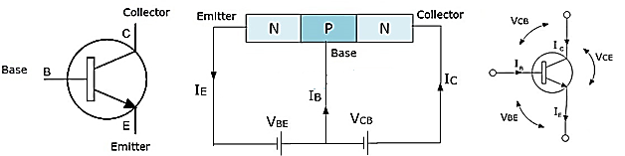

#### PNP Transistor

The PNP is another type of Bipolar Junction Transistors (BJT). The PNP transistors contain two p-type semiconductor materials and are separated by a thin layer of n-type semiconductor. The majority charge carriers in the PNP transistors are holes and electrons are minority charge carriers. The arrow in the emitter terminal of transistor indicates the flow of conventional current. In PNP transistor the current flows from Emitter to Collector. The PNP transistor is ON when the base terminal is pulled to LOW with respect to emitter. The symbol and structure for PNP transistor is shown below.

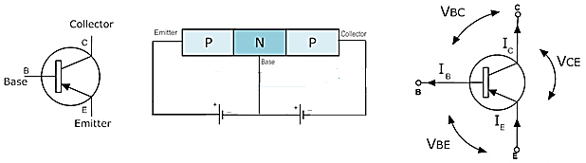

#### ****FET (Field Effect Transistor)****

The Field-Effect-Transistor (FET) is another transistors type. Basically the FET transistors have three terminals they are gate (G), Drain (D) and Source (S). FET transistors are classified into Junction Field Effect transistors (JFET) and Insulated Gate FET (IG-FET) or MOSFET transistors. For the connections in the circuit we also consider fourth terminal called base or substrate. The FET transistors have control on the size and shape of a channel between source and drain which is created by applied voltage. The FET transistors are uni-polar transistors because they perform single channel operation where as BJT transistors are bipolar junction transistors. The FET transistors have high current gain than BJT transistors.

#### JFET (Junction-Field Effect Transistor)

The Junction-Field-Effect transistor (JFET) is an earliest and simple type of FET transistors. These JFETs are used as switches, amplifiers and resistors. This transistor is a voltage controlled device. It doesn’t need any biasing current. The voltage applied between gate and source controls the flow of electric current between source and drain of a transistor. The JFET transistors are available in both N-channel and P-channel types.

#### N-Channel JFET

In N-channel JFET the current flow is due to the electrons. When voltage is applied between gate and source, a channel is formed between source and drain for current flow. This channel is called N-channel. Nowadays N-channel JFET transistor is most preferable type than P-channel JFET. The symbols for N-channel JFET transistor are given below.

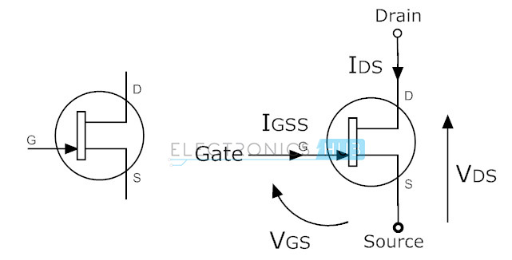

#### P-Channel JFET

In this JFET transistor the current flow is because of holes. The channel between source and drain is called P-channel. The symbols for P-channel JFET transistors are given below. Here arrow marks indicates the direction of current flow.

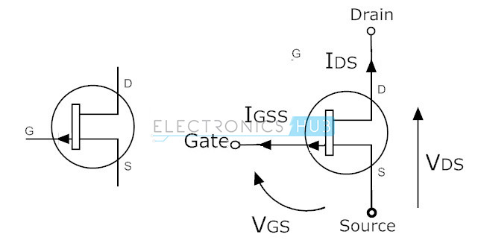

#### ****MOSFET****

Metal-Oxide-Semiconductor Field Effect Transistor (MOSFET) is most useful type of among all transistors. The name itself indicates that it contains metal gate terminal. The MOSFET has four terminals drain, source, gate and body or substrate (B). MOSFET has many advantages over BJT and JFET, mainly it offer high input impedance and low output impedance. It is used in low power circuits mainly in chip designing technologies.The MOSFET transistors are available in depletion and enhancement types. Further the depletion and enhancement types are classified into N-channel and P-channel types.

#### N-Channel MOSFET

The MOSFET having N-channel region between source and drain is called N-channel MOSFET. Here the source and gate terminals are heavily doped with n-type materials and substrate is doped with p-type semiconductor material. Here the current flow between source and drain is because of electrons. The gate voltage controls the current flow in the circuit. N-channel MOSFET is most preferable than P-channel MOSFET because the mobility of electrons is high than mobility of holes. The symbols for N-channel MOSFET transistors are given below.

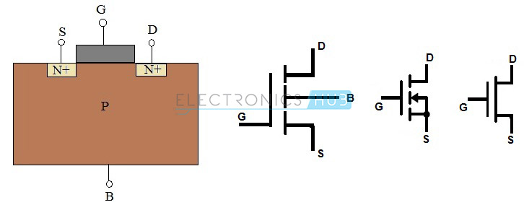

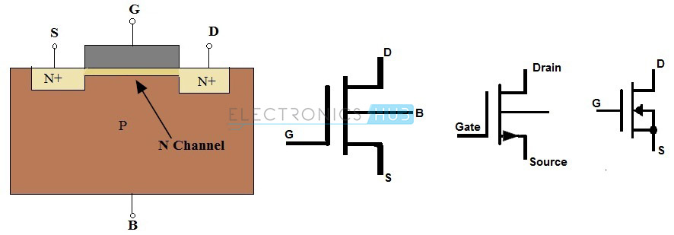

#### P- Channel MOSFET

The MOSFET having P-channel region between source and drain is called as P-channel MOSFET. Here the source and drain terminals are heavily doped with P-type material and the substrate is doped with N-type material. The current flow between source and drain is because of holes concentration. The applied voltage at gate will controls the flow of current through channel region. The symbols for P-channelMOSFET transistors in depletion and enhancement types are given below.

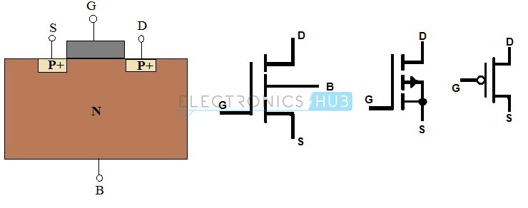

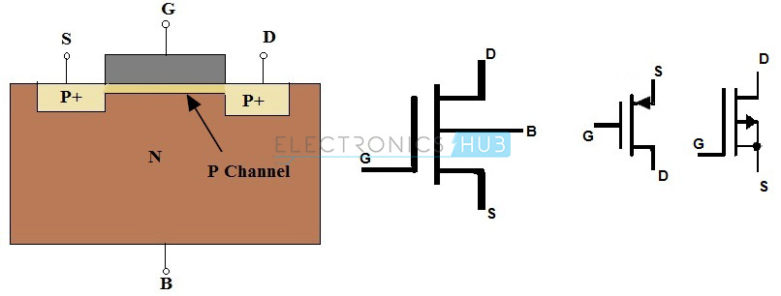

**Digital storage oscilloscope** (DSO)

A **digital storage oscilloscope** (often abbreviated **DSO**) is an oscilloscope which stores and analyses the signal digitally rather than using analog techniques. It is now the most common type of oscilloscope in use because of the advanced trigger, storage, display and measurement features which it typically provides.

The input analogue signal is sampled and then converted into a digital record of the amplitude of the signal at each sample time. The sampling frequency should be not less than the Nyquist rate to avoid aliasing. These digital values are then turned back into an analogue signal for display on a cathode ray tube (CRT), or transformed as needed for the various possible types of output—liquid crystal display, chart recorder, plotter or network interface.

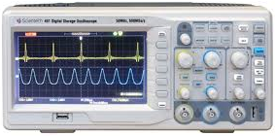

Digital storage oscilloscope

### Cathode-Ray Oscilloscope(CRO)

Cathode-ray oscilloscope (CRO) is a common laboratory instrument that provides accurate time and aplitude measurements of voltage signals over a wide range of frequencies. Its reliability, stability, and ease of operation make it suitable as a general purpose laboratory instrument. The heart of the CRO is a cathode-ray tube

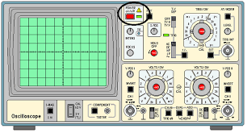

### Cathode-Ray Oscilloscope

**THE BREADBOARD**

The breadboard consists of two terminal strips and two bus strips (often broken in the center). Each bus strip has two rows of contacts. Each of the two rows of contacts are a node. That is, each contact along a row on a bus strip is connected together (inside the breadboard). Bus strips are used primarily for power supply connections, but are also used for any node requiring a large number of connections. Each terminal strip has 60 rows and 5 columns of contacts on each side of the center gap. Each row of 5 contacts is a node. You will build your circuits on the terminal strips by inserting the leads of circuit components into the contact receptacles and making connections with 22-26 gauge wire. There are wire cutter/strippers and a spool of wire in the lab. It is a good practice to wire +5V and 0V power supply connections to separate bus strips.

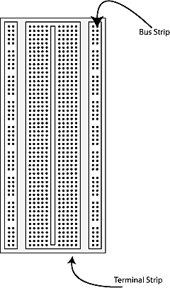

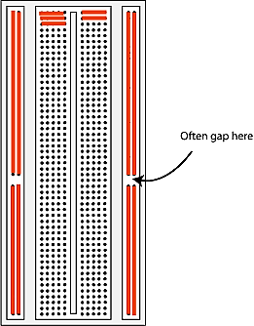

**The lines indicate connected holes.**

 The 5V supply **MUST NOT BE EXCEEDED** since this will damage the ICs (Integrated circuits) used during the experiments. Incorrect connection of power to the ICs could result in them exploding or becoming very hot - with the possible serious injury occurring to the people working on the experiment! Ensure that the power supply polarity and all components and connections are correct before switching on power Supply.

**Building the Circuit**

Throughout these experiments we will use TTL chips to build circuits. The steps for wiring a circuit should be completed in the order described below:

|  |
| --- |
| 1. Turn the power (Trainer Kit) off before you build anything! |
| 1. Make sure the power is off before you build anything! |
| 1. Connect the +5V and ground (GND) leads of the power supply to the power and ground bus strips on your breadboard. |
| 1. Plug the chips you will be using into the breadboard. Point all the chips in the same direction with pin 1 at the upper-left corner. (Pin 1 is often identified by a dot or a notch next to it on the chip package) |
| 1. Connect +5V and GND pins of each chip to the power and ground bus strips on the breadboard. |
| 1. Select a connection on your schematic and place a piece of hook-up wire between corresponding pins of the chips on your breadboard. It is better to make the short connections before the longer ones. Mark each connection on your schematic as you go, so as not to try to make the same connection again at a later stage. |
| 1. Get one of your group members to check the connections, **before you turn the power on**. |
| 1. If an error is made and is not spotted before you turn the power on. Turn the power off immediately before you begin to rewire the circuit. |
| 1. At the end of the laboratory session, collect you hook-up wires, chips and all equipment and return them to the demonstrator. |
| 1. Tidy the area that you were working in and leave it in the same condition as it was before you started. |

**Common Causes of Problems**

|  |
| --- |
| 1. Not connecting the ground and/or power pins for all chips. |
| 1. Not turning on the power supply before checking the operation of the circuit. |
| 1. Leaving out wires. |
| 1. Plugging wires into the wrong holes. |
| 1. Driving a single gate input with the out puts of two or more gates |
| 1. Modifying the circuit with the power on. |

**Multimeter**

A **multimeter**  also known as a **VOM** (volt-ohm-millimeter), is an electronic measuring instrument that combines several measurement functions in one unit. A typical multimeter can measure voltage, current, and resistance. **Analog multimeter** use a micrometer with a moving pointer to display readings. **Digital multimeter** (DMM, DVOM) have a numeric display, and may also show a graphical bar representing the measured value. Digital multimeter are now far more common due to their cost and precision, but analog multimeter are still preferable in some cases, for example when monitoring a rapidly varying value.

A multimeter can be a hand-held device useful for basic fault finding and field service work, or a bench instrument which can measure to a very high degree of accuracy. They can be used to troubleshoot electrical problems in a wide array of industrial and household devices such as electronic equipment, motor controls, domestic appliances, power supplies, and wiring systems.

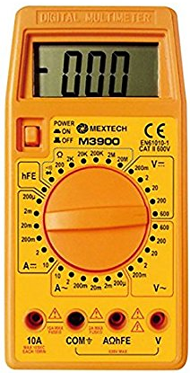

DIGITAL MULTIMETER

**EXPERIMENT NO-2**

**TO STUDY AND PLOT THE V-I**

**CHARACTERISTICS OF P-N**

**JUNCTION**

**DIODE AND ZENER DIODE**

**(A)-CHARACTERISTICS OF Si-DIODE**

**AIM:** To study the PN junction diode characteristics under Forward & Reverse bias conditions.

**APPARATUS REQUIRED**:

|  |  |  |  |  |
| --- | --- | --- | --- | --- |
| **S.No** | **Name** | **Range** | **Type** | **Quantity** |
| **1** | Regulated power supply | (0-30)V | DC | 1 |
| **2** | Ammeter | (0-200) mA (for [Forward](http://www.electrical4u.com/pn-junction/) bias)(0-200)µA (for [Reverse Bias](http://www.electrical4u.com/pn-junction/)) | DC | 1 |
| **3** | Voltmeter | (0-20)V (for [Forward](http://www.electrical4u.com/pn-junction/) bias) (0-30)V(for [Reverse Bias](http://www.electrical4u.com/pn-junction/)) | DC | 1 |
| **4** | Si Diode | 1N4007 |  | 1 |
| **5** | Resistor | 1KΩ |  | 1 |
| **6** | Breadboard |  |  | 1 |
| **7** | Wires |  |  |  |

**THEORY:** A PN junction diode is a two terminal junction device. Itconducts only in one direction (only on forward biasing).

**FORWARD BIAS:** On forward biasing, initially no current flows due to barrier potential. As the applied potential exceeds the barrier potential the charge carriers gain sufficient energy to cross the potential barrier and hence enter the other region. The holes which are majority carriers in the P-region, become minority carriers on entering the N-regions, and electrons, which are the majority carriers in the N-region become minority carriers on entering the P-region.

**REVERSE BIAS:** On reverse biasing, the majority charge carriers are attracted towards the terminals due to the applied potential resulting in the widening of the depletion region. Since the charge carriers are pushed towards the terminals no current flows in the device due to majority charge carriers. There will be some current in the device due to the thermally generated minority carriers. The generation of such carriers is independent of the applied potential and hence the current is constant for all increasingreverse potential. This current is referred to as reverse Saturation Current (IO) and it increases with temperature. When the applied reverse voltage is increased beyond the certain limit, it results in breakdown. During breakdown, the diode current increases tremendously.

CIRCUIT DIAGRAM:

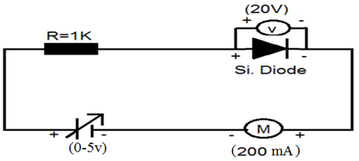

**FORWARD BIAS**

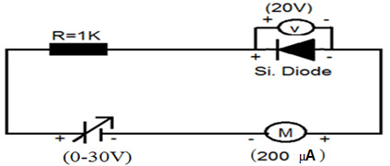

**REVERSE BIAS**

Specification for 1N4001: Silicon Diode

Peak Inverse Voltage: 50V

Idc= 1A.

Maximum forward voltage drop at 1 Amp is 1.1 volts

Maximum reverse current @50 volts is 5µA

**OBSERVATIONS:**

1. Find the d.c (static) resistance = V/I.
2. Find the a.c (dynamic) resistance r = (r = V/I) =V2-V1 / I2-I1
3. .Find the forward voltage drop = [Hint: it is equal to 0.7 for Si and 0.3 forGe.].

**Measurement in forward bias**

|  |  |  |  |
| --- | --- | --- | --- |
| **S. No.** | **Input voltage** | **Diode Voltage(Vd)** | **Current(mA) (Id)** |
| 1.  2.  3  4.  5.  6.  7.  8.  9.  10.  11.  12.  13.  14. | 0.1V  0.2V  0.3V  0.4V  0.5V  0.6V  0.7V  0.8V  0.9V  1 V  2 V  3 V  4 V  5 V |  |  |

**Measurement in reverse bias**

|  |  |  |  |
| --- | --- | --- | --- |
| S.No. | Input Voltage | Diode Voltage (Vd) | Current (µA)(Id) |
| 1. | 2V |  |  |
| 2. | 4V |  |  |
| 3. | 6V |  |  |
| 4. | 8V |  |  |
| 5. | 10V |  |  |
| 6. | 12V |  |  |
| 7. | 14V |  |  |
| 8. | 16V |  |  |
| 9. | 18V |  |  |
| 10. | 20V |  |  |
| 11. | 22V |  |  |
| 12. | 24V |  |  |
| 13. | 26V |  |  |
| 14. | 28V |  |  |
| 15. | 30V |  |  |

**MODEL GRAPH**

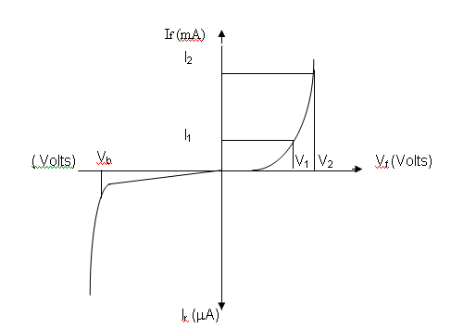

**FORWARD BIAS:**

1. Connect the circuit as per the diagram.

2. Vary the applied voltage V in steps of 0.1V.

3. Note down the corresponding Ammeter readings I.

4. Plot a graph between V & I

**REVERSE BIAS:**

1. Connect the circuit as per the diagram.

2. Vary the applied voltage V in steps of 1.0V.

3. Note down the corresponding Ammeter readings I.

4. Plot a graph between V & I.

### 5. Find the dynamic resistance r = ∆V / ∆I

**RESULT:**

Forward and Reverse bias characteristics of the PN junction diode and the dynamic resistance under

* Forward bias = ---------------------
* Reverse bias = ----------------------.
* Reverse Saturation Current = ----------------.

**PRECAUTIONS:**

1. While doing the experiment do not exceed the ratings of the diode. This may lead to damage of the diode.

2. Connect voltmeter and Ammeter in correct polarities as shown in the circuit diagram.

3. Do not switch ON the power supply unless you have checked the circuit connections as per the circuit diagram

**(B)-CHARACTERISTICS OF ZENER DIODE**

**AIM**: **Plot the V-I Characteristics of Zener Diode in forward and reverse bias condition and to determine the breakdown voltage of a given zener diode**

**APPARATUS REQUIRED:**

|  |  |  |  |  |
| --- | --- | --- | --- | --- |
| **S No** | **Name** | **Range** | **Type** | **Quantity** |
| **1** | **Regulated power supply** | (0-30)V | DC | 1 |
| **2** | **Ammeter** | **(0-200)mA**(for [Forward](http://www.electrical4u.com/pn-junction/) bias  **(0-200)µA**(for Revers bias) | DC | 1 |
| **3** | **Voltmeter** | **(0-20)V**(for [Forward](http://www.electrical4u.com/pn-junction/) bias)  **(0-200)V** (for Revers bias) | DC | 1 |
| **4** | **ZenerDiode** | FZ.6.1 |  | 1 |
| **5** | **Resistor** | 1KΩ |  | 1 |
| **6** | **Breadboard** |  |  | 1 |
| **7** | **Wires** |  |  |  |

**THEORY:** A properly doped crystal diode, which has a sharp breakdown voltage, is known as zener diode.

**FORWARD BIAS:**On forward biasing, initially no current flows due to barrier potential. As the applied potential increases, it exceeds the barrier potential at one value and the charge carriers gain sufficient energy to cross the potential barrier and enter the other region. the holes ,which are majority carriers in p-region, become minority carriers on entering the N-regions and electrons, which are the majority carriers in the N-regions become minority carriers on entering the P-region. This injection of minority carriers results current, opposite to the direction of electron movement.

**REVERSE BIAS:** When the reverse bias is applied due to majority carriers small amount of current (i.e) reverse saturation current flows across the junction. As the reverse bias is increased to breakdown voltage, sudden rise in current takes place due to zener effect.

**ZENER EFFECT:** Normally, PN junction of Zener Diode is heavily doped. Due to heavy doping the depletion layer will be narrow. When the reverse bias is increased the potential across the depletion layer is more. This exerts a force on the electrons in the outermost shell. Because of this force the electrons are pulled away from the parent nuclei and become free electrons. This ionization, which occurs due to electrostatic force of attraction, is known as Zener effect. It results in large number of free carriers, which in turn increases the reverse saturation current.

**FORWARD BIAS:**

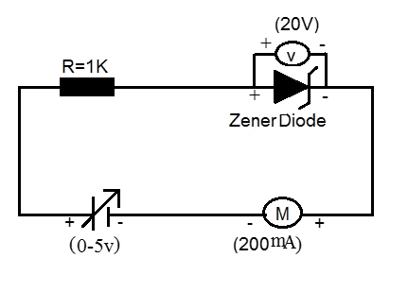

REVERSE BIAS:

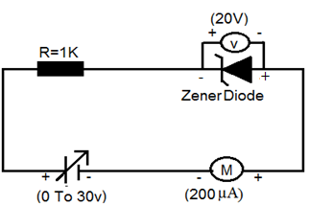

**Measurement in forward bias**

|  |  |  |  |
| --- | --- | --- | --- |
| **S.No.** | **Input voltage** | **Diode Voltage (VD)** | **Current (mA)** |
| **1.**  **2.**  **3.**  **4.**  **5.**  **6.**  **7.**  **8.**  **9.**  **10.**  **11.**  **12.**  **13.**  **14.** | **0.1V**  **0.2V**  **0.3V**  **0.4V**  **0.5V**  **0.6V**  **0.7V**  **0.8V**  **0.9V**  **01V**  **02V**  **03V**  **04V**  **05V** |  |  |

**Measurement in reverse bias**

|  |  |  |  |
| --- | --- | --- | --- |
| **S.No** | **Input Voltage** | **Diode Voltage (Vz)** | **Current (µA)** |
| **1**  **2**  **3**  **4**  **5**  **6**  **7**  **8**  **9**  **10**  **11**  **12**  **13**  **14**  **15** | **1v**  **2v**  **3v**  **4v**  **5v**  **6v**  **7v**  **8v**  **9v**  **10v**  **11v**  **12v**  **13v**  **14v**  **15v** |  |  |

**MODEL GRAPH**

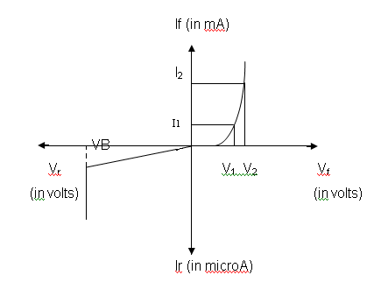

**PROCEDURE:**

**FORWARD BIAS**

1. Connect the circuit as per the circuit diagram.

2 .Vary the power supply in such a way that the readings are taken in steps

of 0.1V in the voltmeter till the needle of power supply shows 30V.

3. Note down the corresponding ammeter readings.

4. Plot the graph V.d .(vs) I.

5. Find the dynamic resistance r = V / I.

**REVERSE BIAS**

1. Connect the circuit as per the diagram.

2. Vary the power supply in such a way that the readings are taken in steps of 0.1V in the voltmeter till the needle of power supply shows 30V.

3. Note down the corresponding Ammeter readings I.

4. Plot a graph between V & I.

5. Find the dynamic resistance r = V / I.

6. Find the reverse voltage Vr at Iz=20 mA.

**RESULT:**

Forward and Reverse bias characteristics of the zener diode was studied and

Forward bias dynamic resistance = ---------------------

Reverse bias dynamic resistance = ----------------------

The reverse voltage at Iz=20 mA determined from the reverse characteristics of the Zener diode is --------------------------.

**EXPERIMENT NO-3**

**TO STUDY AND SET UP A HALF WAVE AND FULL WAVE RECTIFIER CIRCUIT. AND TO CALCULATE ITS FORM FACTOR, RIPPLE FACTOR AND EFFICIENCY**

**(A)-HALF WAVE RECTIFIER**

**AIM: To construct a Half wave rectifier using diode and to draw its performance characteristics**.

**APPARATUS REQUIRED:**

|  |  |  |  |  |
| --- | --- | --- | --- | --- |
| **S No** | **Name** | **Range** | **Type** | **Quantity** |
| **1** | **Transformer** | 230/(9-0-9)V | Step down | 1 |
| **2** | **Diode** | 1N4007 |  | 1 |
| **3** | **Resistor** | 1KΩ |  | 1 |
| **4** | **Breadboard** |  |  | 1 |
| **5** | **Connecting Wires** |  |  |  |
| **6** | **Digital storage oscilloscope(DSO)/Cathode Ray oscilloscope (CRO)** |  |  | 1 |

**THEORY-**A diode is a unidirectional conducting device. It conducts only when its anodes is at cycle of the input, the diode gets forward biased and it conducts .current flows through the load resistor RL and a higher voltage with respect to its cathode. In a half wave rectifier circuit during positive half voltage is developed across it. During negative half cycle of the input, the diode gets reverse biased. Now no current (except the leakage current which is very small) flows. The voltage across the load resistance during this period of input cycle is zero. Thus a pure AC signal is converted into a unidirectional signal. It can be show that

## =

Where,

is the output DC voltage and  is peak AC voltage at the input of rectifier circuit.

220v/6v

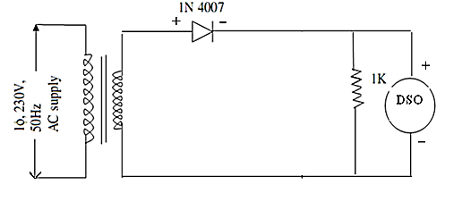**CIRCUIT DIAGRAM FOR HALF WAVE RECTIFIER**

Ripple factor =

**PROCEDURE:**

**1**. Connect the primary side of the transformer to the AC mains. Connect the CRO/DSO probes to the output points. Adjust the CRO/DSO so that a good and stable wave shape is visible on it screen. Plot this wave form in your record book. Take the CRO/DSO probes at the input points of the rectifier. Note the wave shape of the signal. Compare them.

**2.** Now use a multi meter to measure the AC voltage at the secondary terminals of the transformer. This given the r.m.s value. Also measure the AC & DC voltage at the output points.

**3.** Multiply this r.m.s value by  to get the peak value. Calculate the theoretical value of DC voltage using formula  = Compare this value with the practically measured value of output DC voltage.

**4.** Using the measured value of DC and AC output voltages calculate ripple factor.

## CALCULATION:

## 1. =

## 2. =

## 3. Form factor =

## 4. Ripple =

**MODEL GRAPH:**

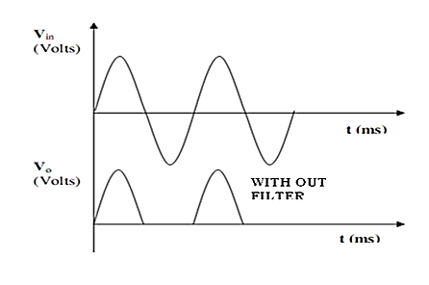

## OBSERVATION:

|  |  |  |
| --- | --- | --- |
|  | **Theoretical value** | **Practical value** |
|  | **-** |  |
|  | **-** |  |
| **Form factor** | **1.57** |  |
| **Ripple factor** | **1.21** |  |

## RESULT: We have studied the half wave rectifier using one diode in forward condition & calculated its ripple factor & form factor.

**(B)-FULL WAVE RECTIFIER**

**AIM: To construct a Full wave rectifier using diode and to draw its performance characteristics.**

**APPARATUS REQUIRED:**

|  |  |  |  |  |
| --- | --- | --- | --- | --- |
| S No | Name | Range | Type | Quantity |
| 1 | Transformer | 230V / (9-0-9)V | AC | 1 |
| 2 | Si Diode | 1N4007 |  | 2 |
| 3 | Resistor | 1KΩ |  | 1 |
| 4 | Breadboard |  |  | 1 |
| 5 | Connecting Wires |  |  |  |
| 6 | Digital storage oscilloscope(DSO)/Cathode Ray oscilloscope (CRO) |  |  | 1 |

## THEORY:-

## In a full wave rectifier circuit there are two diodes, a transformer and a load resistor. The transformer has a center-tap in its secondary winding. It provides out -of –phase voltage to the two diodes. During the positive half cycle of the input, the diode D2 is reverse biased and it does not conduct. But diode D1 is forward biased and it conduct. The current flowing through D1 also passes through the load resistor and a voltage is developed across it. During the negative half cycle, the diode D2 is forward biased and D1 is reverse biased. Now, current flow through diode D2 & load resistor. The current flowing through load resistor RL passes in the same direction in both the half cycles. The DC voltage obtained at the output is given as

# 

Where, is the peak value of the AC voltage between the centre-tap point and one of the diode.

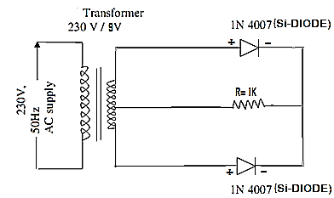

**Circuit diagram for full wave rectifier**

##### **PROCEDURE:**

##### **1**. Connect the mains voltage to the primary of the center – tapped transformer. Connect the output terminals to the CRO/DSO. Adjust the CRO/DSO at the center –tap and one of the diode. Observe the wave shape on the CRO/DSO. Plot both the wave shape in your record book. Compare the two voltage wave shapes.

2. Measure AC voltage at the input and output points. Also measure the DC voltage across the load resistor.

3. from the measured AC voltage. Calculate the DC voltage. Compare it with the measured value of DC output voltage. Now calculate the ripple factor by dividing AC voltage (at the output) by DC voltage at the output.

## CALCULATION:

## 

## 

# 3. Form factor =

## 4. Ripple factor =

**MODEL GRAPH**

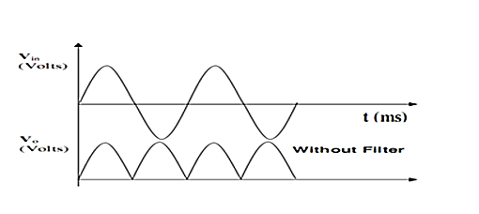

## OBSERVATION:

|  |  |  |
| --- | --- | --- |
|  | **Theoretical value** | **Practical value** |
|  | **-** |  |
|  | **-** |  |
| **Form factor** | **1.11** |  |
| **Ripple factor** | **0.48** |  |

## RESULT:We have studied the full wave rectifier circuit using two diode in forward condition & calculated its ripple factor & form factor.

**(C)-BRIDGE RECTIFIER**

**AIM: To construct a bridge rectifier using diode and to draw its performance characteristics**.

**APPARATUS REQUIRED:**

|  |  |  |  |  |
| --- | --- | --- | --- | --- |
| **S No** | **Name** | **Range** | **Type** | **Quantity** |
| **1** | **Transformer** | **230V / (9-0-9)V** | AC | 1 |
| **2** | **Si Diode** | 1N4007 |  | 4 |
| **3** | **Resistor** | 1KΩ |  | 1 |
| **4** | **Breadboard** |  |  | 1 |
| **5** | **Connecting Wires** |  |  |  |
| **6** | **Digital storage oscilloscope(DSO)/Cathode Ray oscilloscope (CRO)** |  |  | 1 |

## THEORY:

In a Bridge rectifier circuit there are four diodes, a transformer and a load resistor. When the input voltage is positive at point A diode and  conduct. The current passes through the load resistor .during the other half cycle of the input signal. The point A is negative with respect to the point B. the diode and conduct. The current passes through the load resistor in the same direction as during the positive half cycle. DC voltage is developed across the load. It can be proved that the output DC voltage is given by

# 

Where is the peak AC voltage at the input of the rectifier.

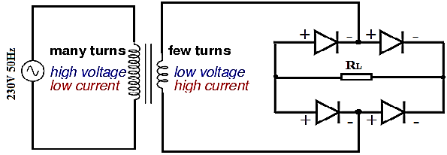

**Circuit diagram of bridge rectifier**

## PROCEDURE:

**1**. Energize the rectifier with the AC mains. Connect the output of the rectifier to the CRO/DSO. Adjust the CRO/DSO till you get a stable pattern on the rectifier. Compare the two wave shapes.

**2.** Now measure the AC voltage at the secondary of the transformer. Also measure AC & DC voltage at the output points

**3.** Using the theoretical formula -

# 

Calculate the DC voltage at the output. Compare this value with the measured DC voltage. Use the measured values of AC & DC voltage at the output points. To calculate the ripple factor Compare this value with the theoretical value.

## CALCULATION:

1. 

2. 

3. Form factor = 

4. Ripple factor = 

## OBSERVATION:

|  |  |  |
| --- | --- | --- |
|  | **Theoretical value** | **Practical value** |
|  | **-** |  |
|  | **-** |  |
| **Form factor** | **1.11** |  |
| **Ripple factor** | **0.48** |  |

## RESULT:-

We have studied the bridge rectifier & calculate it’s ripple factor & form factor.

**EXPERIMENT NO-4**

**TO STUDY THE CLIPPER CIRCUITS AND TO PLOT THE WAVE FORM**

**(A)-CLIPPERS CIRCUITS**

**AIM: To Study various clippers circuits using diodes.**

**APPARATUS REQUIRED:**

|  |  |  |  |  |
| --- | --- | --- | --- | --- |
| S No | Name | Range | Type | Quantity |
| 1 | Digital storage oscilloscope(DSO)/Cathode Ray oscilloscope (CRO) | 40MHz |  | 1 |
| 2 | Regulated power supply | (0-30)V | AC/DC | 2 |
| 3 | Diode (Si Diode) |  | 1N4007 | 1 |
| 4 | Resistor | 1KΩ |  | 1 |
| 5 | Breadboa rd |  |  | 1 |
| 6 | Function Generator | 1MHz |  | 1 |
| 7 | Wires |  |  |  |

**THEORY:**

The diode clipper, also known as a *Diode Limiter*, is a wave shaping circuit that takes an input waveform and clips or cuts off its top half, bottom half or both halves together. This clipping of the input signal produces an output waveform that resembles a flattened version of the input. For example, the half-wave rectifier is a clipper circuit, since all voltages below zero are eliminated. But Diode Clipping Circuits can be used a variety of applications to modify an input waveform using signal and Scotty diodes or to provide over-voltage protection using zener diodes to ensure that the output voltage never exceeds a certain level protecting the circuit from high voltage spikes. Then diode clipping circuits can be used in voltage limiting applications.

We saw in the signal diode tutorial that when a diode is forward biased it allows current to pass through itself clamping the voltage. When the diode is reverse biased, no current flows through it and the voltage across its terminals is unaffected, and this is the basic operation of the diode clipping circuit.

Although the input voltage to diode clipping circuits can have any waveform shape, we will assume here that the input voltage is sinusoidal. Consider the circuits below.

Related Products:

**(A)-Positive parallel clipper Circuits**

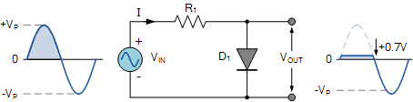

In this diode clipping circuit, the diode is forward biased (anode more positive than cathode) during the positive half cycle of the sinusoidal input waveform. For the diode to become forward biased, it must have the input voltage magnitude greater than +0.7 volts (0.3 volts for a germanium diode).

When this happens the diodes begins to conduct and holds the voltage across itself constant at 0.7V until the sinusoidal waveform falls below this value. Thus the output voltage which is taken across the diode can never exceed 0.7 volts during the positive half cycle.

During the negative half cycle, the diode is reverse biased (cathode more positive than anode) blocking current flow through itself and as a result has no effect on the negative half of the sinusoidal voltage which passes to the load unaltered. Then the diode limits the positive half of the input waveform and is known as a positive clipper circuit.

**(B)-Negative parallel clipper Circuits**

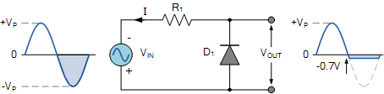

Here the reverse is true. The diode is forward biased during the negative half cycle of the sinusoidal waveform and limits or clips it to -0.7 volts while allowing the positive half cycle to pass unaltered when reverse biased. As the diode limits the negative half cycle of the input voltage it is therefore called a negative clipper circuit.

**Biased Diode Clipping Circuits**

To produce diode clipping circuits for voltage waveforms at different levels, a bias voltage, VBIAS is added in series with the diode as shown. The voltage across the series combination must be greater than VBIAS + 0.7V before the diode becomes sufficiently forward biased to conduct. For example, if the VBIAS level is set at 4.0 volts, then the sinusoidal voltage at the diode’s anode terminal must be greater than **4.0 + 0.7 = 4.7 volts** for it to become forward biased. Any anode voltage levels above this bias point are clipped off.

**(a)-Positive Bias Diode Clipping**

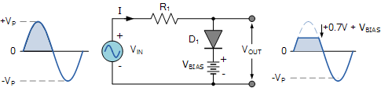

Likewise, by reversing the diode and the battery bias voltage, when a diode conducts the negative half cycle of the output waveform is held to a level -VBIAS – 0.7V as shown.

**(b)-Negative Bias Diode Clipping**

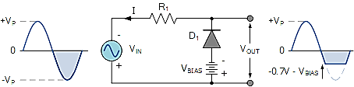

A variable diode clipping or diode limiting level can be achieved by varying the bias voltage of the diodes. If both the positive and the negative half cycles are to be clipped, then two biased clipping diodes are used. But for both positive and negative diode clipping, the bias voltage need not be the same. The positive bias voltage could be at one level, for example 4 volts, and the negative bias voltage at another, for example 6 volts as shown.

## Series clipper

## (a)-Series positive clipper

In series positive clipper, the positive half cycles of the input AC signal is removed. If the diode is arranged in such a way that the arrowhead of the diode points towards the input and the diode is in series with the output load resistance, then the clipper is said to be a series positive clipper. In the circuit diagram, the diode D1 is connected in series with the output load resistance RL and the arrowhead of the diode is pointing towards the input. So the circuit is said to be a series positive clipper.

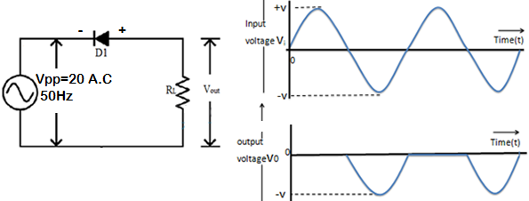

Cathode is connected to the power supply and anode is maintained at ground potential.

* **During Positive Half Cycle:** Output voltage (VO) = 0 Volts
* **During Negative Half Cycle:** Output voltage (VO) = (Vin + Vd) Volts

Where Vd is the Diode Threshold Voltage.

**(b)- Series Negative Clipper**

A series negative clipper is basically a half wave rectifier circuit. Consider a circuit shown in the Fig. Where diode is connected in series with the load. Let us analyze this circuit. For a positive half cycle, the diode D1 is forward biased. Hence the voltage waveform across RLlooks like a positive half cycle of the input voltage.

While for a negative half cycle, diode D1 is reverse biased and hence will not conduct at all. Hence there will not be any voltage available across resistance RL. Hence the negative half cycle of input voltage gets clipped off. The input waveform and the corresponding output voltage waveform is shown in the Fig.

For an ideal diode, the output voltage will reach to the same maximum level as that of input, during positive half cycle.

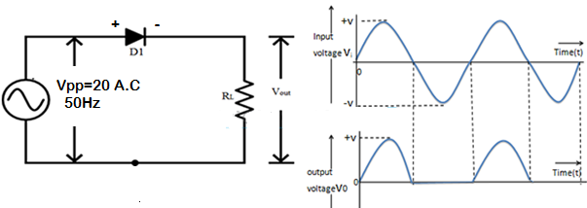

Anode is connected to the power supply and the cathode is maintained at ground potential.

* **During Positive Half Cycle:** Output voltage (VO) = (Vin – Vd) Volts
* **During Negative Half Cycle:** Output voltage (VO) = 0 Volts

**PROCEDURE:**

1. Set up the circuit one by one after testing the components. Apply 20V peak to peak sine at the input.
2. Observe the input & output waveforms simultaneously on the CRO screen keeping AC-DC switch of the CRO in DC position.
3. Note the values & plot the waveform.

**RESULT- ……………………………………………………………..**

**EXPERIMENT NO. 5**

**TO STUDY THE CLAMPER CIRCUITS AND TO PLOT THE WAVE FORM**

**CLAMPING CIRCUITS**

**AIM: To Study various clamping circuits using diodes.**

**APPARATUS REQUIRED:**

|  |  |  |  |
| --- | --- | --- | --- |
| S.NO. | Name of the Apparatus | Range | Quantity |
| 1 | Bread Board | - | 1 |
| 2 | Capacitor | 1µF | 1 |
| 3 | DC source | 3 V | 1 |
| 4 | Si Diode | 1N4007 | 1 |
| 5 | C.R.O./D.S.O. | - | 1 |
| 6 | Wire | - | 6 |
| 7 | Function Generator/AC Power supply | - | 1 |

**THEORY:**

In some situations, it is necessary to add or subtract a dc voltage to a given waveform without changing its shape. Circuits used for this purpose are called clamping circuits. This can be achieved by connecting a dc source in series with the input. DC sources are very expensive and bulky equipment’s. A capacitor which is charged to a voltage & subsequently prevented from discharging can serve as a suitable replacement for a dc source. This principle is utilized in clamping circuits. The clamping level can be made at any voltage level by biasing the diode. Such a clamping circuit is called a biased clamper.

**(A)-Positive clamper clamping at 0 V:**

Suppose the input voltage is represented by theexpression VmSin*w*t. During one negative half cycle of the input sine wave, the diode conducts and the capacitor charges to Vm with positive polarity at the right side of the capacitor. During the positive half of the input sine wave, the capacitor cannot discharge since the diode does not conduct. Thus capacitor acts as a dc source of Vm volts in series with input signal source. The output voltage then can be expressed as Vo = Vm + VmSin*w*t

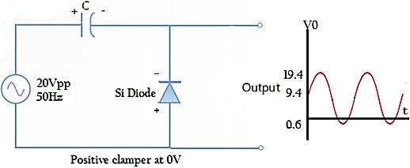

**(B)-Negative clamper clamping at 0 V:**

Suppose the input voltage is represented by theexpression VmSin*w*t. During one positive half cycle of the input sine wave, the diode conducts and the capacitor charges to Vm with positive polarity at the right

side of the capacitor. During the positive half of the input sine wave, the capacitor cannot discharge since the diode does not conduct. Thus capacitor acts as a dc source of Vm volts in series with input signal source. The output voltage then can be expressed as Vo = - Vm + VmSin*w*t

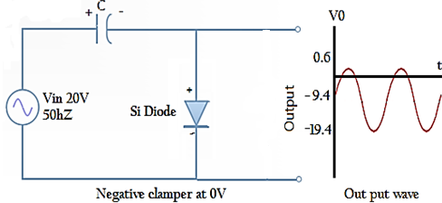

**(C)-Positive clamper clamping at + 3V:**

During one negative half cycle of the inputsine wave, capacitor charges through the dc source and diode till ( Vm + 3) volts with positive polarity of the capacitor at its right side. The charging of the capacitor is limited to (Vm + 3) volts due to the presence of the dc source. The output is then expressed as Vo = (Vm + 3) + VmSin*w*t

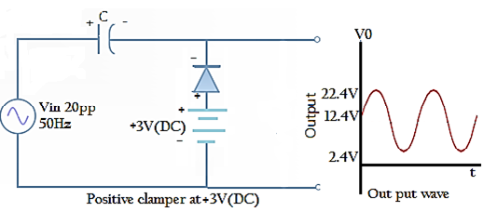

**(D)-Negative clamper clamping at + 3V:**

During one positive half cycle of the inputsine wave, capacitor charges through the dc source and diode till ( Vm - 3) volts with negative polarity of the capacitor at its right side. The charging of the capacitor is limited to (Vm - 3) volts due to the presence of the dc source. The output is then expressed as Vo = -(Vm - 3) + V mSin*w*t

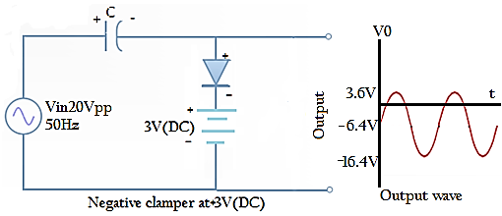

**PROCEDURE:**

* + 1. Set up the circuit one by one after testing the components. Apply 20V peak to peak sine at the input.
    2. Observe the input & output waveforms simultaneously on the CRO screen keeping AC-DC switch of the CRO in DC position.
    3. Note the values & plot the waveform.

**RESULT- …………………………………………………………………**

**EXPERIMENT NO-6**

**STUDY OF TRANSISTOR CHARACTERISTICS COMMON EMITTER (NPN)**

## AIM: Study of the characteristics of NPN transistor in common emitter configuration and to evaluate:

**1. Input resistance**

**2. Output resistance**

**3. Current gain**

## MATERIAL REQUIREDS:

**Components:**

| **S.No.** | **Name** | **Quantity** |
| --- | --- | --- |
| 1 | Transistor BC 107 | 1(One) No. |
| 2 | Resistors (1Khttp://i.imgur.com/6fz6IHX.gif, 100Khttp://i.imgur.com/6fz6IHX.gif) | 1(One) No. Each |
| 3 | Bread board | 1(One) No. |

**Equipment:**

| **S.No.** | **Name** | **Quantity** |
| --- | --- | --- |
| 1 | Dual DC Regulated Power supply (0 - 30 V) | 1(One) No. |
| 2 | Digital Ammeters  (0 - 200 mA, 0-200 http://i.imgur.com/YoyOvED.gifA) | 1(One) No. Each |
| 3 | Digital Voltmeter (0 - 20V) | 2(Two) No. |
| 4 | Connecting wires (Single Strand) |  |

## THEORY: A transistor is a semiconductor device used to amplify or switch electronic signals and electrical power. It is composed of semiconductor material with at least three terminals for connection to an external circuit. A voltage or current applied to one pair of the transistor's terminals changes the current through another pair of terminals. Because the controlled (output) power can be higher than the controlling (input) power, a transistor can amplify a signal.

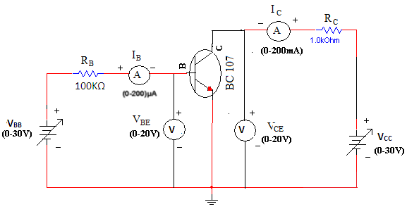

**Common emitter Input Output configuration (NPN)**

Input Characteristic**:** In common emitter configuration, it is the curve plotted between the input current (IB) verses input voltage (VBE) for various constant values of output voltage (VCE).

This characteristic reveal that for fixed value of output voltage VCE, as the base to emitter voltage increases, the emitter current increases in a manner that closely resembles the diode characteristics.

The input resistance is calculated using the formula,

**Observations:**

| **Input CharacteristicsInput Characteristics** | | | | |
| --- | --- | --- | --- | --- |
| **VBB (Volts)** | **VCE = 1V** | | **VCE = 5V** | |
| **VBE(Volts)** | **IB(µA)** | **VBE(Volts)** | **IB(µA)** |
|  |  |  |  |  |
|  |  |  |  |  |
|  |  |  |  |  |
|  |  |  |  |  |
|  |  |  |  |  |

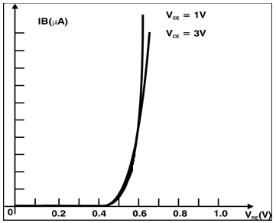

## Input characteristics of CE (NPN) figure 1

Output Characteristic***:*** This is the curve plotted between the output current IC verses output voltage VCE for various constant values of input current IB.

The output characteristic has three basic region of interest as indicated in figure 2 the active region, cutoff region and saturation region.

In active region the collector base junction is reverse biased while the base emitter junction if forward biased. This region is normally employed for linear (undistorted) amplifier.

In cutoff region the collector base junction and base emitter junction of the transistor both are reverse biased. In this region transistor acts as an ‘Off’ switch.

In saturation region the collector base junction and base emitter junction of the transistor both are forward biased. In this region transistor acts as an on switch.

| **Output Characteristics** | | | | | | |
| --- | --- | --- | --- | --- | --- | --- |
| **VCC(Volts)** | **IB = 0 µA** | | **IB = 20 µA** | | **IB = 40 µA** | |
| **VCE(Volts)** | **IC(mA)** | **VCE(Volts)** | **IC(mA)** | **VCE(Volts)** | **IC(mA)** |
|  |  |  |  |  |  |  |
|  |  |  |  |  |  |  |
|  |  |  |  |  |  |  |
|  |  |  |  |  |  |  |
|  |  |  |  |  |  |  |



## Output characteristics of CE (NPN)

**Procedure:**

**Input Characteristics:**

1. Connect the circuit as shown in the circuit diagram.
2. Keep output voltage **VCE** = 0V by varying **VCC**.
3. Varying **VBB** gradually, note down base current **IB** and base-emitter voltage **VBE**.
4. Step size is not fixed because of nonlinear curve. Initially vary **VBB** in steps of 0.1V. Once the current starts increasing vary **VBB** in steps of 1V up to 12V.
5. Repeat above procedure (step 3) for **VCE** = 5V.

**Output Characteristics:**

1. Connect the circuit as shown in the circuit diagram.
2. Keep emitter current **IB** = 20http://i.imgur.com/YoyOvED.gifA by varying **VBB**.
3. Varying **VCC** gradually in steps of 1V up to 12V and note down collector current **IC** and Collector-Emitter Voltage (**VCE**).
4. Repeat above procedure (step 3) for **IB** = 60µA, 0µA.

**Result:**

Input and Output characteristics of a Transistor in Common Emitter Configuration are studied.

**EXPERIMENT NO-7**

**STUDY OF TRANSISTOR CHARACTERISTICS COMMON BASE (NPN)**

## AIM:-Study the characteristics of NPN transistor in common base configuration and to evaluate

**1. Input resistance**

**2. Output resistance**

MATERIAL REQUIREDS**:**

**Components:**

| **S.No.** | **Name** | **Quantity** |
| --- | --- | --- |
| 1 | Transistor BC 107 | 1(One) No. |
| 2 | Resistors (1Khttp://i.imgur.com/6fz6IHX.gif) | 2(Two) No. |
| 3 | Bread board | 1(One) No. |
|  |  |  |

**Equipment:**

| **S.No.** | **Name** | **Quantity** |
| --- | --- | --- |
| 1 | Dual DC Regulated Power supply (0 – 30 V) | 1(One) No. |
| 2 | Digital Ammeters  ( 0 – 200 mA) | 2(Two) No. |
| 3 | Digital Voltmeter (0-20V) | 2(Two) No. |
| 4 | Connecting wires (Single Strand) | 2 |

## THEORY:-A Transistor is three terminal active device. The three terminals are emitter, base & collector. In common base configuration, we make the base common to both input & output.

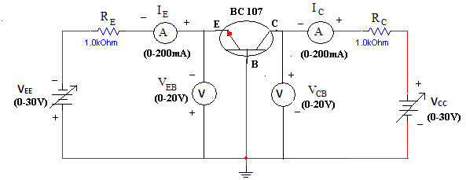

**Common base Input /Output configuration (NPN)**

## Input Characteristic: In common base configuration, it is the curve plotted between the input current (IE) versus input voltage () for various constant values of output voltage (VCB).

This characteristic is very similar to that of a forward-biased diode characteristics. The input resistance is calculated using the formula



**Observations:**

|  |  |  |  |  |  |  |
| --- | --- | --- | --- | --- | --- | --- |
| **Input Characteristics** | | | | | | |
| **VEE (Volts)** | **VCB = 0V** | | **VCB = 8V** | | **VCB = 18V** | |
| **VEB (Volts)** | **IE (mA)** | **VEB (Volts)** | **IE (mA)** | **VEB (Volts)** | **IE (mA)** |
|  |  |  |  |  |  |  |
|  |  |  |  |  |  |  |
|  |  |  |  |  |  |  |
|  |  |  |  |  |  |  |
|  |  |  |  |  |  |  |

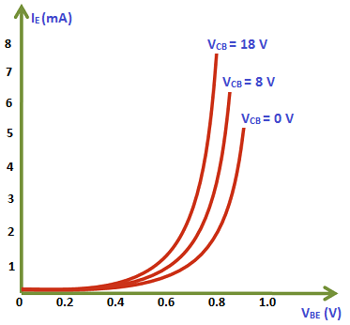

**Graph-Input characteristics of CB (NPN)**

Output Characteristic***:*** This is the curve plotted between the output current IC versus output voltage VCB for various constant values of input current IE. These curves are almost horizontal. This shows that the output dynamic resistance is very high,

# 

|  |  |  |  |  |  |  |
| --- | --- | --- | --- | --- | --- | --- |
| **Output Characteristics** | | | | | | |
| **VCC (Volts)** | **IE = 0mA** | | **IE = 1mA** | | **IE = 2mA** | |
| **VCB (Volts)** | **IC (mA)** | **VCB (Volts)** | **IC (mA)** | **VCB (Volts)** | **IC (mA)** |
|  |  |  |  |  |  |  |
|  |  |  |  |  |  |  |
|  |  |  |  |  |  |  |
|  |  |  |  |  |  |  |
|  |  |  |  |  |  |  |



**Graph-Output characteristics of CB (NPN)**

**Input Characteristics:**

1. Connect the circuit as shown in the circuit diagram.
2. Keep output voltage V*CB*= 0V by varying VCC.
3. Varying V*EE* gradually, note down emitter current I*E* and emitter-base voltage (V*EE*).
4. Step size is not fixed because of nonlinear curve. Initially vary VEE in steps of 0.1 V. Once the current starts increasing vary VEE in steps of 1V up to 12V.
5. Repeat above procedure (step 3) for V*CB*= 4V.

**Output Characteristics:**

1. Connect the circuit as shown in the circuit diagram.
2. Keep emitter current I*E*= 5mA by varying V*EE*.
3. Varying V*CC* gradually in steps of 1V up to 12V and note down collector current IC and collector-base voltage (VCB).
4. Repeat above procedure (step 3) for IE = 10mA.

Repeat above procedure (step 3) for I*E*= 10mA.

## RESULT: Thus the characteristics of Transistor (NPN) in common base configuration has been verified and the graph has been plotted according to the observation and to evaluate-

1. Input resistance 2. Output resistance

**EXPERIMENT NO-8**

**TO DESIGN AN INVERTING APMLIFIER WITH A GAIN OF -10 (USING OP-AMP)**

**INTRODUCTION**

**741 OP-AMP**

Generally, operational amplifiers are extremely high voltage gain op-amps and they are standard building blocks of analogue circuits. The most commonly used op-amp is IC741. The 741 op-amp is a voltage amplifier, it inverts the input voltage at the output, can be found almost everywhere in electronic circuits.

Let’s see the pin configuration and testing of 741 op-amps. Usually, this is a numbered counter clockwise around the chip. It is an 8 pin IC. They provide superior performance in integrator, summing amplifier and general feedback applications. These are high gain op-amp; the voltage on the inverting input can be maintained almost equal to Vin.

It is a 8-pin dual-in-line package with a pinout shown above.

Pin 1: Offset null.

Pin 2: Inverting input terminal.

Pin 3: Non-inverting input terminal.

Pin 4: –VCC (negative voltage supply).

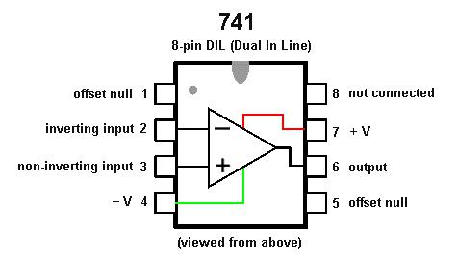Pin 5: Offset null.

Pin 6: Output voltage.

Pin 7: +VCC (positive voltage supply).

Pin 8: No Connection

**AIM: Design and realize Inverting amplifier using 741 Op-amp.**

**Apparatus Required:** CRO, Function Generator, Bread Board, 741 IC, ±12V supply,Resistors 1KΩ, 10KΩ, and Connecting leads.

**Theory:**

An inverting amplifier using op-amp is a type of amplifier using op-amp where the output waveform will be phase opposite to the input waveform. The input waveform will be amplifier by the factor Av (voltage gain of the amplifier) in magnitude and its phase will be inverted. In the inverting amplifier circuit the signal to be amplified is applied to the inverting input of the op-amp through the input resistance R1. Rf is the feedback resistor. Rf and Rin together determine the gain of the amplifier. Inverting operational amplifier gain can be expressed using the equation Av = – Rf/R1. Negative sign implies that the output signal is negated. The circuit diagram of a basic inverting amplifier using op-amp is shown below.

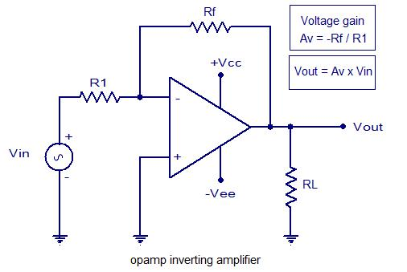

The input and output waveforms of an inverting amplifier using op-amp is shown below. The graph is drawn assuming that the gain (Av) of the amplifier is 2 and the input signal is a sine wave. It is clear from the graph that the output is twice in magnitude when compared to the input (Vout = Av x Vin) and phase opposite to the input.

**Practical inverting amplifier using 741.**

A simple practical inverting amplifier using 741 IC is shown below. uA 741 is a high performance and of course the most popular operational amplifier. It can be used in a verity of applications like integrator, differentiator, voltage follower, amplifier etc. uA 741 has a wide supply voltage range (+/-22V DC) and has a high open loop gain. The IC has an integrated compensation network for improving stability and has short circuit protection.

Signal to be amplified is applied to the inverting pi (pin2) of the IC. Non inverting pin (pin3) is connected to ground. R1 is the input resistor and Rf is the feedback resistor. Rf and R1 together sets the gain of the amplifier. With the used values of R1 and Rf the gain will be 10

(Av = -Rf/R1 = 10K/1K = 10). RL is the load resistor and the amplified signal will be available across it. POT R2 can be used for nullifying the output offset voltage. If you are planning to assemble the circuit, the power supply must be well regulated and filtered. Noise from the power supply can adversely affect the performance of the circuit. When assembling on PCB it is recommended to mount the IC on the board using an IC base.

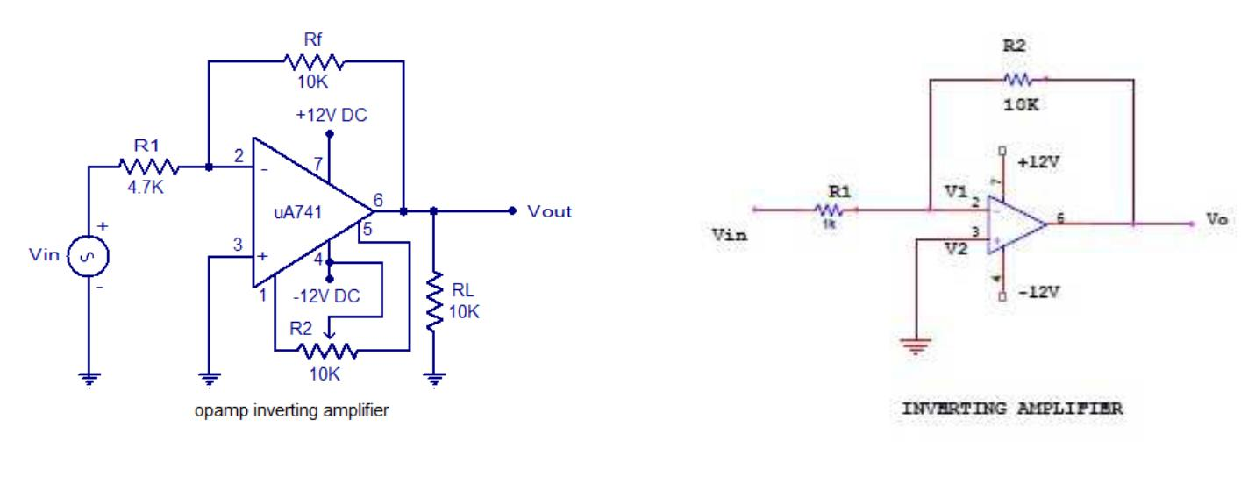In the inverting amplifier only one input is applied and that is to the inverting input (V2) terminal. The Non inverting input terminal (V1) is grounded.

Since, V1=0 V& V2=Vin

Vo= -A Vin

The negative sign indicates the output voltage is 1800 out of phase with respect to the input and amplified by gain A.

**Procedure:**

1. Connect the circuit for inverting amplifier on a breadboard.
2. Connect the input terminal of the op-amp to function generator and output terminal to CRO.
3. Feed input from function generator and observe the output on CRO.
4. Draw the input and output waveforms on graph paper.

**Output Waveform:**

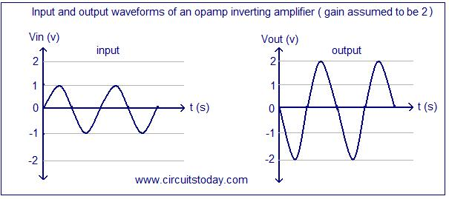

**EXPERIMENT NO-9**

**TO DESIGN AN NON-INVERTING APMLIFIER WITH A GAIN OF -10 (USING OP-AMP)**

**AIM: Design and realize Non-inverting amplifier using 741 Op-amp.**

**Apparatus Required:** CRO, Function Generator, Bread Board, 741 IC, ±12V supply,Resistors 1KΩ, 10KΩ, and Connecting leads.

**Theory:**

An non-inverting amplifier using opamp is a type of amplifier using opamp where the output waveform will be in phase to the input waveform. The input waveform will be amplified by the factor Av (voltage gain of the amplifier) in magnitude and its phase will not be inverted. In the non-inverting amplifier circuit the signal to be amplified is applied to the non-inverting input of the opamp through the input resistance R1. Rf is the feedback resistor. Rf and Rin together determine the gain of the amplifier. Non-Inverting operational amplifier gain can be expressed using the equation Av = 1+ Rf/R1. The circuit diagram of a basic non-inverting amplifier using opamp is shown below.

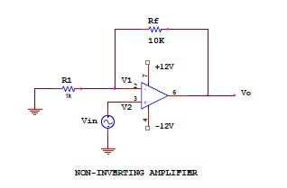

**Practical inverting amplifier using 741.**

A simple practical non-inverting amplifier using 741 IC is shown below. uA 741 is a high performance and of course the most popular operational amplifier. It can be used in a verity of applications like integrator, differentiator, voltage follower, amplifier etc. uA 741 has a wide supply voltage range (+/-22V DC) and has a high open loop gain. The IC has an integrated compensation network for improving stability and has short circuit protection.

Signal to be amplified is applied to the non-inverting pin (pin3) of the IC. Inverting pin (pin2) is connected to ground. R1 is the input resistor and Rf is the feedback resistor. Rf and R1 together sets the gain of the amplifier. With the used values of R1 and Rf the gain will be 10.

RL is the load resistor and the amplified signal will be available across it. POT R2 can be used for nullifying the output offset voltage. If you are planning to assemble the circuit, the power supply must be well regulated and filtered. Noise from the power supply can adversely affect the performance of the circuit. When assembling on PCB it is recommended to mount the IC on the board using an IC base.

**Practical Non-inverting amplifier using 741:**

The input is applied to the non-inverting input terminal and the Inverting terminal is connected to the ground.

V1= Vin & V2=0 Volts

Vo= A Vin

The output voltage is larger than the input voltage by gain A & is in phase with the input signal.



**Procedure:**

1. Connect the circuit for non inverting amplifier on a breadboard.
2. Connect the input terminal of the op-amp to function generator and output terminal to CRO.
3. Feed input from function generator and observe the output on CRO.
4. Draw the input and output waveforms on graph paper.

**Output Waveform:**

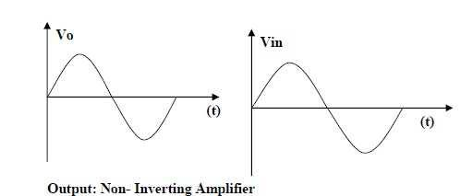

**EXPERIMENT NO. 10**

**TO DESIGN AN ADDER CIRCUIT FOR SUMMING 3 INPUT VOLTAGE SIGNALS (USING OP-AMP)**

**AIM: Design and verify the operations of op amp adder (summing) circuit using 741 Op-amp.**

**Apparatus Required:** CRO, Function Generator, Bread Board, 741 IC, ±12V supply,Resistors, and Connecting leads.

**Theory:**

**Adder (Summing Amplifier):**

Op-amp may be used to perform summing operation of several input signals in inverting in inverting and non-inverting mode. The input signals to be summed up are given to inverting terminal or non-inverting terminal through the input resistance to perform inverting and non-inverting summing operations respectively.

If the input to the inverting amplifier is increased, the resulting circuit is known as adder. Output is a linear summation of number of input signals. Each input signal produces a component of the output signal that is completely independent of the other input signal. When there are two inputs i.e.

Vo= - (V1+V2)

This is the inverted algebraic sum of all the inputs. If we connect the inputs to non inverting terminal then the adder is non inverting adder.

Vo= - (Va-Vb)

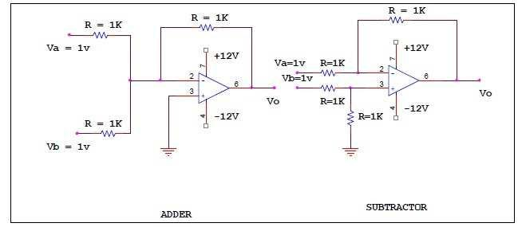

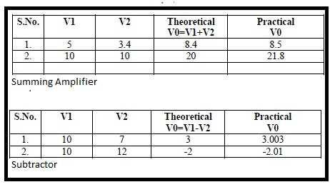

**Procedure:**

1. Apply two different sine waves signal to the input of the adder and subtractor.
2. Give the input amplitude of 5v peak to peak and frequency of 1 kHz.
3. Verify the output on CRO.

